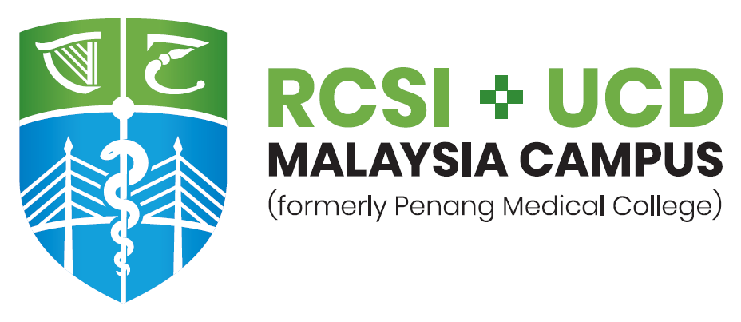
RCSI & UCD RUMC SCHOLARSHIP 2022
RUMC MEDICINE PROGRAMME

Read the Application Procedure and the Terms & Conditions carefully before completing the form.
Application Procedure:
- Please submit as a word document.
- False particulars or willful suppression of material facts will render you liable to disqualification. All required documents must be submitted with application.
- Closing date as advertised. Applications received after the closing date will be disqualified.
- Applicants must hold an offer letter from RUMC and have paid a deposit or hold a deposit waiver.
- Applicants must not be bonded to or in receipt of any financial aid or rewards from other educational institutions or organizations.
Terms & Conditions
- Eligibility: Open to all International and Malaysian citizens applying to RCSI & UCD Malaysia Campus.
- Applicants are expected to obtain a minimum of AAA at A-Levels or 38 points excluding bonus points at IBDP or equivalent.
- Applicants must not be bonded to or in receipt of any financial aid or rewards from other educational institutions or organisations.
- Duration: This scholarship is for a total period of 5 years and covers the duration of the medical degree course. It is awarded annually and renewed subject to the scholar attaining an average grade of 2nd class honours (RCSI) or CGPA of 3.2 (UCD) and 2nd class honours (RCSI & UCD Malaysia Campus).
- Amount of Scholarship: The scholarship is not a cash award but covers full tuition fees each year.
- Registration: A scholar must be registered as a full-time medical student at either RCSI or UCD for the first 2.5 years and then at RCSI & UCD Malaysia Campus for the remaining 2.5 years.
- Rules of the College where registered: A scholar will agree to abide by the statutes, policies and procedures of the College of registration.
- Deferment: A scholar may not defer the uptake of the scholarship.
- Promotion of RCSI & UCD (Malaysia): A scholar must commit to participating in RCSI & UCD Malaysia Campus’s promotional activities. This includes participation in the College’s Open Events as a scholar and as an alumnus and the provision of testimonials (e.g. for websites, twitter etc.) on his/her experiences in RCSI & UCD Malaysia Campus and RCSI or UCD as required
- Reports: A scholar must submit six monthly reports outlining academic progress and promotional activities undertaken to the Registrar, RCSI & UCD Malaysia Campus.
- Loss of scholarship: A scholar who fails to meet the conditions of the scholarship will lose the scholarship. Reasons for failure to meet the conditions of the scholarship include not attaining the necessary grades, withdrawing or being suspended by the College from registration or by not participating as required in promotional activities. In the event of loss of scholarship through extenuating circumstances, scholars may appeal in writing to the Registrar, RCSI & UCD Malaysia Campus to have the scholarship reinstated. The appeal must be submitted with supporting documentation, such as a letter from a doctor, within two weeks of loss of scholarship. For this to be considered a scholar’s leave from the University should not exceed two consecutive years.

RCSI & UCD RUMC SCHOLARSHIP 2022
APPLICATION FORM
SECTION A: PERSONAL DETAILS
Full Name (as in IC/passport):  Full Name: Full name | Insert your recent photo here
Passport Number (International) / NRIC (Malaysia):
Insert passport or NRIC here
RUMC Student Reference Number: Please refer to your offer letter
Reference Number
Contact Number:
Enter contact number here
Email Address:
Enter email address here
SECTION B: FAMILY BACKGROUND
Father
Name:  Father’s name. | Age:  Age | Passport / NRIC No.:  Father’s Passport / NRIC
Home Address:  Click here to enter address  Tel: Father’s contact number |  | House: Check only one  ☐Family Owned  ☐Rented
Name and Address of Employer:  Click here to enter address  Tel: Father’s company contact number |  | Occupation:  Father’s occupation

Mother
Name:  Mother’s name  Tel: Mother’s contact number | Age:  Age | Passport / NRIC No.:  Mother’s passport / NRIC
Name and Address of Employer:  Click here to enter address  Tel: Mother’s company contact number |  | Occupation:  Mother’s occupation

Guardian (If Applicable)
Name:  Guardian’s name  Tel: Guardian’s contact number | Age:  Age | Passport / NRIC No.:  Guardian’s passport / NRIC
Name and Address of Employer:  Click here to enter address  Tel: Guardian’s company contact number |  | Occupation:  Guardian’s occupation

NOTE: If your parents / guardians are self-employed, provide the following particulars.

Name and Address of Business:  Enter name and address of business here  Tel: Business contact number | Length of Establishment of Business: | Year(s): Enter Number
 |  | Month(s): Enter Number
Is the Business wholly-owned?
☐Yes
☐No
Nature of Business:  Click here to enter text. | If partnership or joint venture, state share held by parents/guardians.  Click here to enter text.
SECTION C: INCOME
Annual Gross Income of Parents / Guardian (Last Year):
 | Father (RM) | Mother (RM) | Guardian (RM) | Total (RM)
Employment | Insert text | Insert text | Insert text | Insert text
Business | Insert text | Insert text | Insert text | Insert text
Rental | Insert text | Insert text | Insert text | Insert text
Total | Insert text | Insert text | Insert text | Insert text
Other Funding Sources:
It is estimated that students require approximately RM 70,000 per annum to live in Dublin. Please detail any other funding sources, including savings, fixed deposits, relatives etc. that would be used to fund living expenses.
Other Sources | Father (RM) | Mother (RM) | Guardian (RM) | Total (RM)
Fixed Deposit | Insert text | Insert text | Insert text | Insert text
Education Savings | Insert text | Insert text | Insert text | Insert text
Insert text | Insert text | Insert text | Insert text | Insert text
Insert text | Insert text | Insert text | Insert text | Insert text
Insert text | Insert text | Insert text | Insert text | Insert text
Insert text | Insert text | Insert text | Insert text | Insert text
Total | Insert text | Insert text | Insert text | Insert text

Annual Family Expenditure:
Type of Expenditure | Father (RM) | Mother (RM)
House Instalments / Rental | Insert text | Insert text
Electricity / Water | Insert text | Insert text
Telephone | Insert text | Insert text
Loan Repayment (Car / Motor-bike / appliances) | Insert text | Insert text
Transport | Insert text | Insert text
Education | Insert text | Insert text
Others (please specify): | Insert text | Insert text
Insert text | Insert text | Insert text
Total | Insert text | Insert text

Names and Particulars of Siblings / Other Dependents
Name | Relationship | Age | Marital Status | Occupation | Annual Income (RM)
Insert text | Choose an item. | Age | Choose an item. | Insert text | Insert text
Insert text | Choose an item. | Age | Choose an item. | Insert text | Insert text
Insert text | Choose an item. | Age | Choose an item. | Insert text | Insert text
Insert text | Choose an item. | Age | Choose an item. | Insert text | Insert text
Insert text | Choose an item. | Age | Choose an item. | Insert text | Insert text
Insert text | Choose an item. | Age | Choose an item. | Insert text | Insert text

SECTION D: ESSAYS

Please submit an essay on the two topics below. The essays are compulsory and should contain no more than 300 words each. Essays should be submitted in the space provided in the following pages.

RUMC Student Reference No: Enter reference number here
ESSAY 1: “Discuss antibiotic resistance and its future implications.”
Write your essay here

Word Count: Enter word Count
RUMC Student Reference No: Enter reference number here
ESSAY 2: “What contribution has modern medicine made to increased life-expectancy?”
Write your essay here

Word Count: Enter word Count

Please provide a letter from someone who has worked closely with you and who would be able to support you as being a worthy recipient of the scholarship. This person will NOT be the same as the general academic referee. The letter may be from, for example, the school principal, a relevant senior volunteer or a community leader.
When you submit this application, kindly attach a copy of the offer letter that was made to you by RUMC.
SECTION F: DECLARATION BY APPLICANT
- I hereby verify that all information given in this application is complete, true and accurate to the best of my knowledge and that the essays are my own compositions.
- I hereby agree that RCSI & UCD Malaysia Campus has the right to reverse any decision in respect of my application, in the event that the information given is found to be incomplete, inaccurate or false.
- I hereby agree that, if selected to be a scholarship recipient, I will act as Student Ambassador for RCSI & UCD Malaysia Campus and will do so to the best of my ability.
- I undertake to complete the course of study with diligence and to furnish progress reports every 6 months.
- I confirm that I have read and understood the Terms and Conditions of this Scholarship Application.
SECTION E: SUPPORTING DOCUMENTS

NAME: Insert your name here
SIGNATURE:
DATE: Click here to enter a date.

