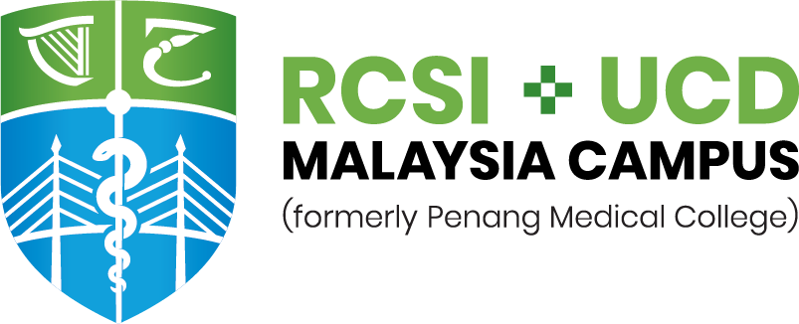
Medical Careers Day Registration Form
Date of Event |  | 23rd February 2019 (Saturday)
Location |  | Novotel KLCC  2 Jalan Kia Peng, 50450, Kuala Lumpur, Malaysia
Registration Fee: RM 50/- applies per person.
Please complete this form using CAPITAL LETTERS.
STUDENT DETAILS – As per NRIC/Passport
Family Name |  |  |  |  |  | First Name |  |  |  |  |  | M |  |  | F
Preferred Name |  |  |  |  |  | Date of Birth |  |  |  |  |  | Age
NRIC No. |  |  |  |  |  | Email
Mobile No. |  |  |  |  |  | Phone No.
Address
PARENT/GUARDIAN CONTACT INFORMATION To be completed if participant is under the age of 18.
Family Name (1) |  |  |  |  |  | First Name |  |  |  |  |  | M |  |  | F
Mobile No. |  |  |  |  |  | Relationship
Email
Family Name (2) |  |  |  |  |  | First Name |  |  |  |  |  | M |  |  | F
Mobile No. |  |  |  |  |  | Relationship
Email
ACADEMIC DETAILS
School Name |  |  |  |  |  |  |  |  |  | Year Level
Address
HOW DID YOU FIND OUT ABOUT THIS PROGRAM? Please mark “X” where applicable
School |  |  |  |  |  | Family |  |  |  |  | Fair
Friend |  |  |  |  |  | Exhibition |  |  |  |  | Other
Agent (please specify):
DIETARY REQUIREMENTS: Please mark “X” where applicable
Note: All food provided by the hotel is Halal.
Non-Vegetarian |  |  | Vegetarian |  |  |  |  | Others (please specify):

PAYMENT INSTRUCTION:
- Upon completion of this registration form, please submit a signed e-copy to events@rcsiucd.edu.my
Account Name | PENANG MEDICAL COLLEGE SDN. BHD.
Bank Name  Branch | CIMB Islamic Bank Berhad  Pulau Tikus Branch  409, Jalan Burmah, 10350, Penang
Account No. | 8602 154 353
Swift Code | CTBBMYKL
- Payment can be made via online banking/transfer or by cash on the event day.

- You will receive a confirmation email from the organiser once your registration is received.
- A copy of the receipt will be issued at the registration counter during the event.
- I hereby verify that all information given in this registration form is complete, true and accurate to the best of my knowledge.
- I hereby agree that RCSI & UCD Malaysia Campus has the right to reverse any decision in respect of my registration, in the event that the information given is found to be incomplete, inaccurate or false.
- I authorise RCSI & UCD Malaysia Campus to communicate with my parents or guardian any information pertaining to the Medical Careers Day.
- I confirm that I have read and understood the Terms and Conditions of this registration form.
- The organisers may at any time, with or without giving notice, in their absolute discretion and without giving any reason, cancel or postpone the Medical Careers Day, change its venue or any of the other published particulars, or withdraw any invitation to attend.
- By agreeing to the Terms and Conditions, you agree to indemnify RCSI & UCD Malaysia Campus and its organisers, officers, employees, agents, volunteers, members or representative, from any loss, liability, damage or expense suffered or incurred by any person.
- All fees paid for the participation in the Medical Careers Day are not refundable under any circumstance.
DISCLAIMER

DECLARATION BY APPLICANT

Signatures
Student's Signature |  | Parent/Guardian's Signature
Student's Name |  | Parent/Guardian's Name
Date |  | Date

